Node Manipulation

- **Instructions**: Use the different tools and modes in Godot to manipulate the nodes in the given image.

Background -> City -> City background 7

Objects -> billboards

Objects -> Clouds - Clouds_Gray -> Shape 6, Shape 2, Shape 1

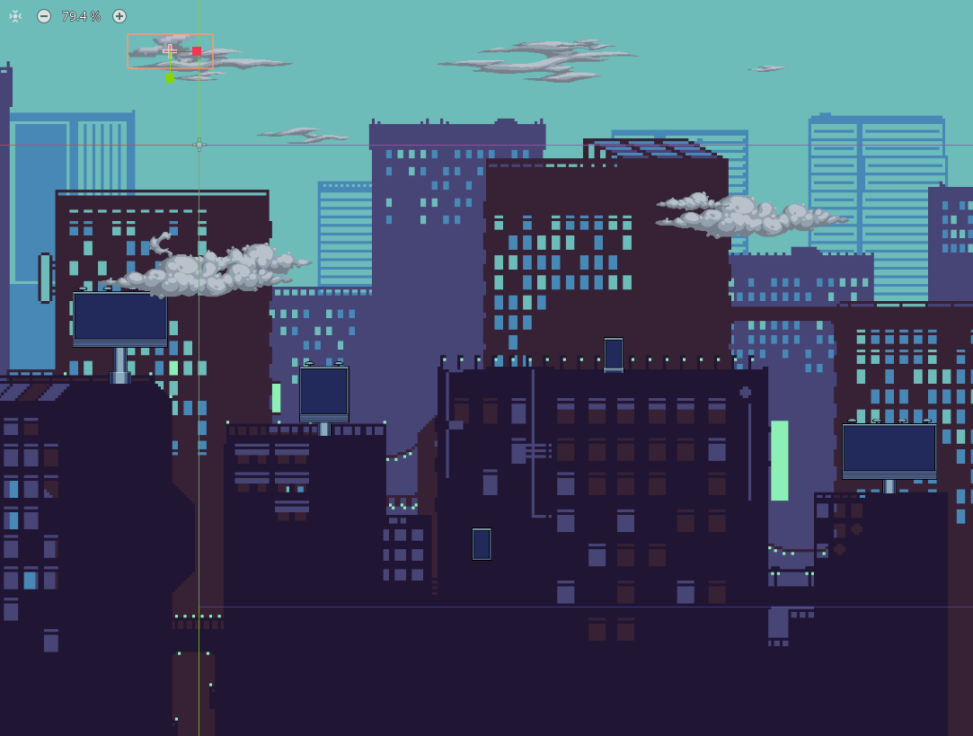

Write down the steps you took to achieve the desired effects.

|  |
| --- |

# Parenting Nodes

- **Instructions**: Answer the following questions about parenting nodes in Godot.

a) Define parenting nodes.

|  |
| --- |

b) How can parenting nodes be useful in game development?

|  |
| --- |

c) Give an example of how properties are inherited by child nodes from their parent nodes.

|  |
| --- |